Screenshots showing the configuration of the OrderItemsReserver Azure Functions.
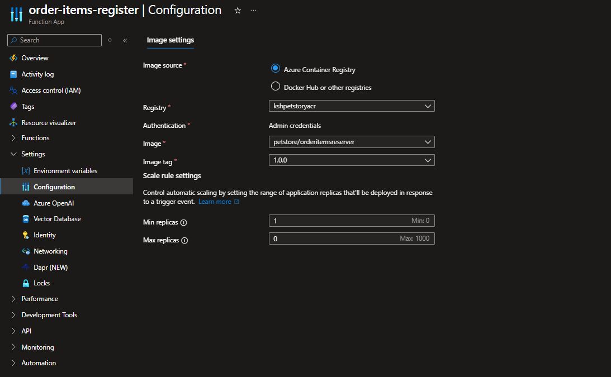
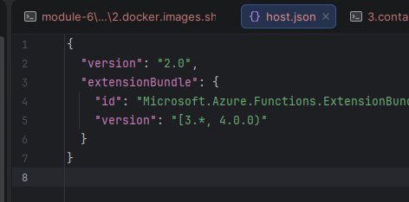
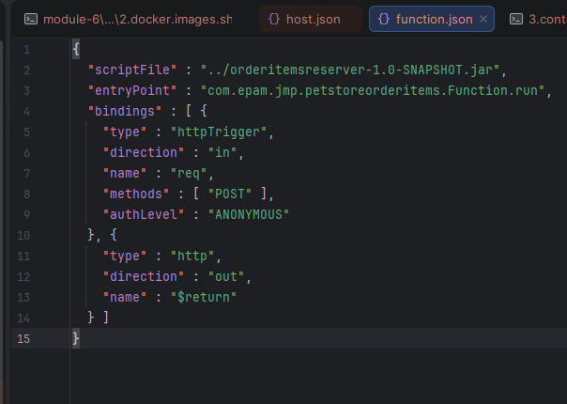
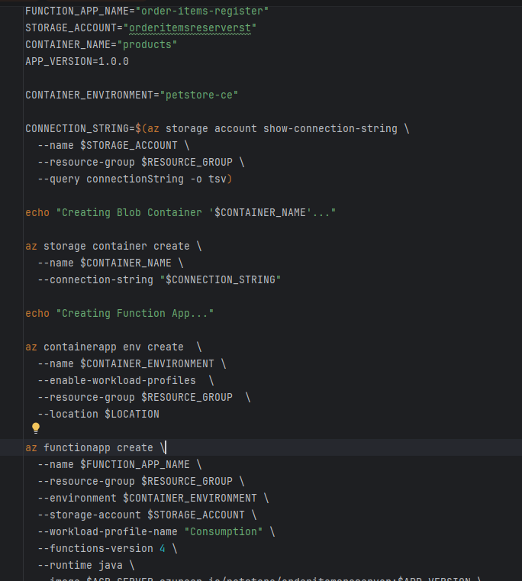
Screenshots verifying that the OrderItemsReserver function has been deployed using container deployment configurations.
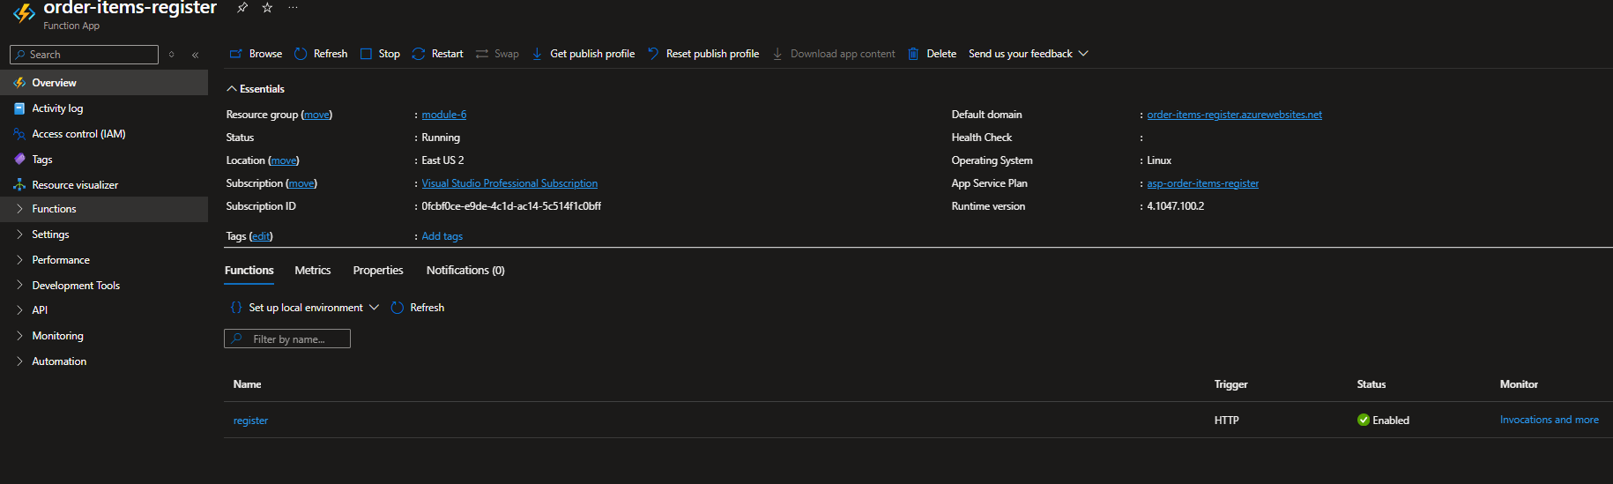
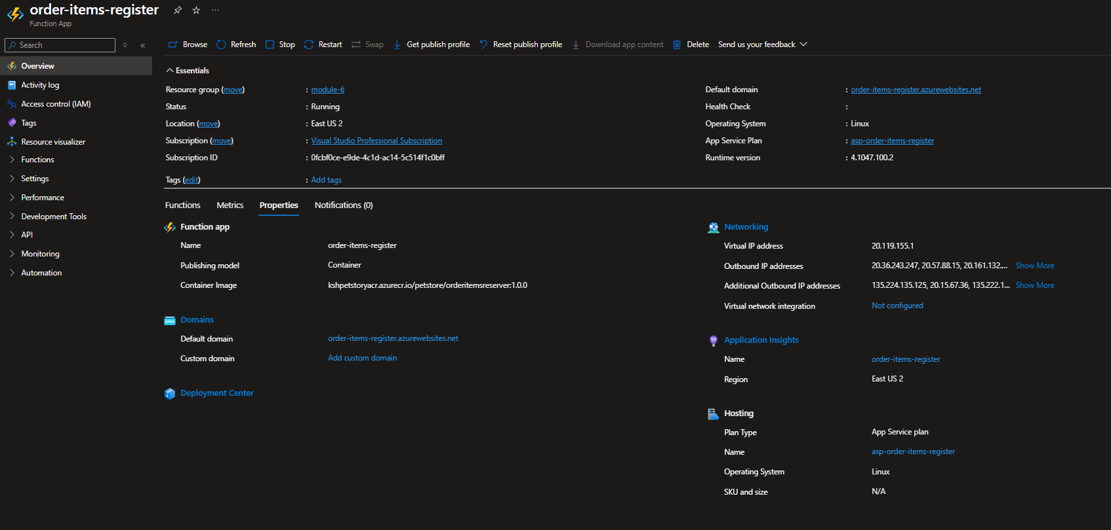

Screenshots displaying the configuration of Blob Storage.
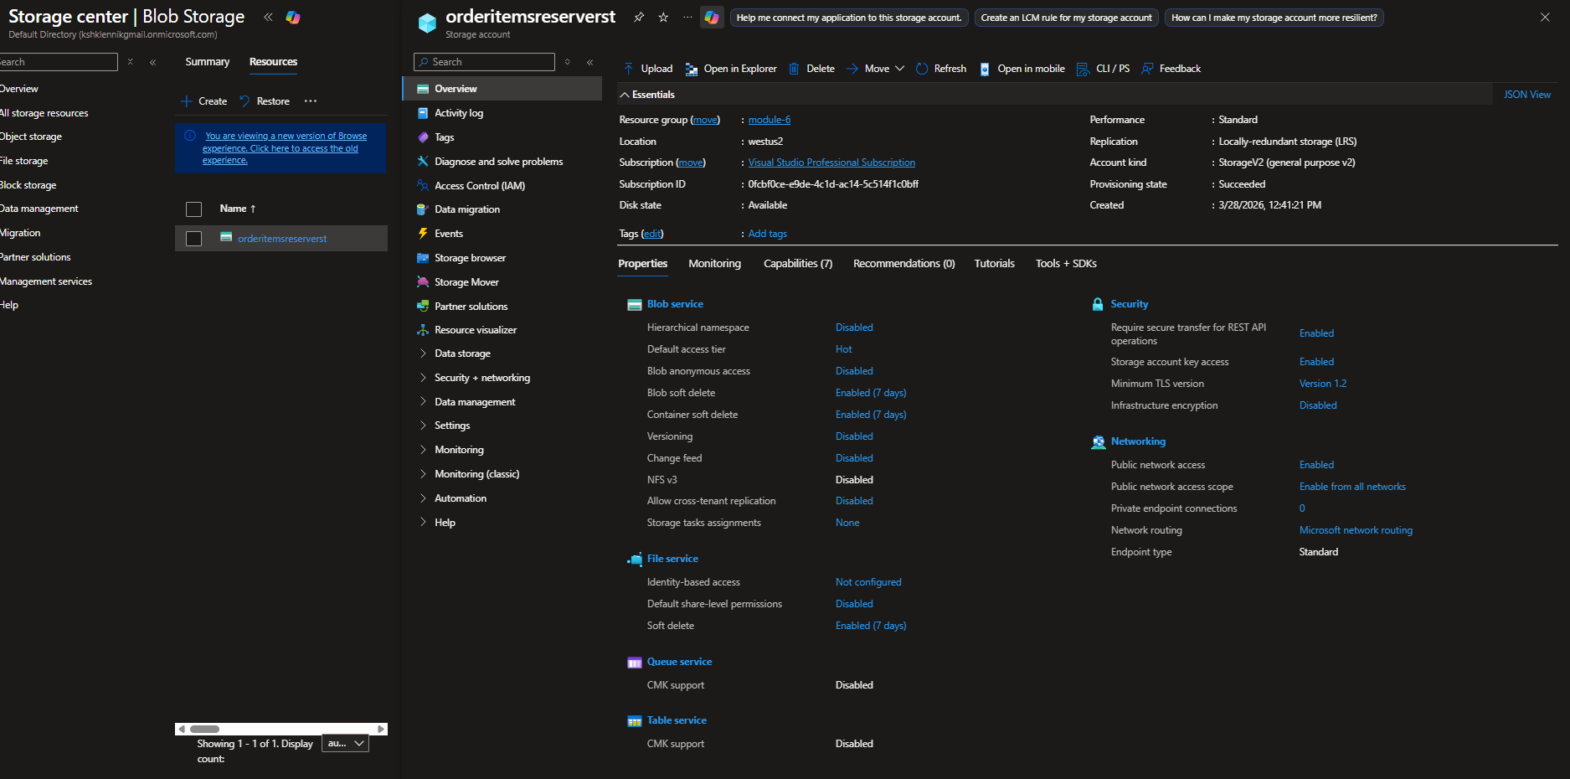
Screenshots of the code within the PetStore application that establishes communication with OrderItemsReserver via an HTTP call.
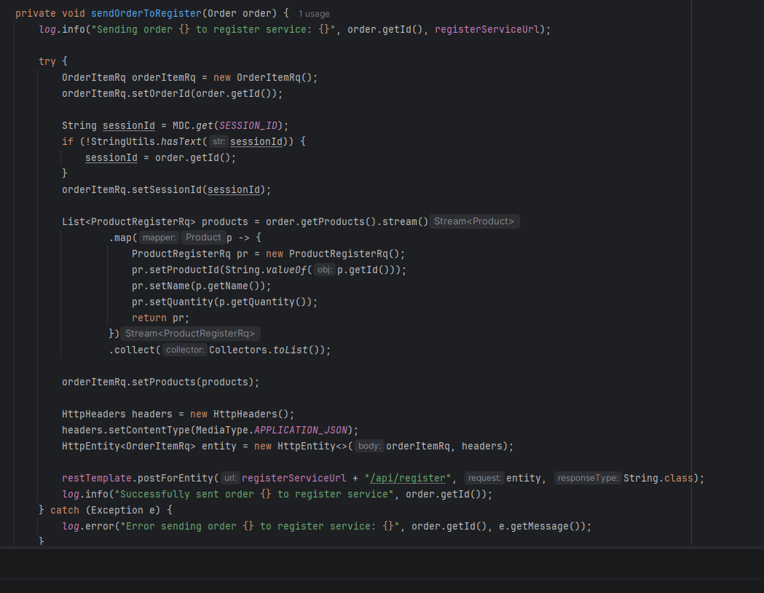
Screenshots highlighting the code section responsible for uploading JSON files to Blob Storage.
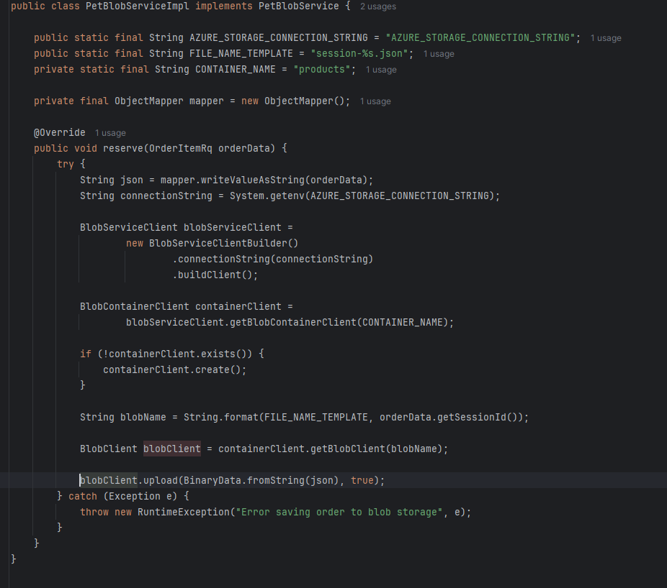
Screenshots of the PetStore application's UI, focusing on the shopping cart section.
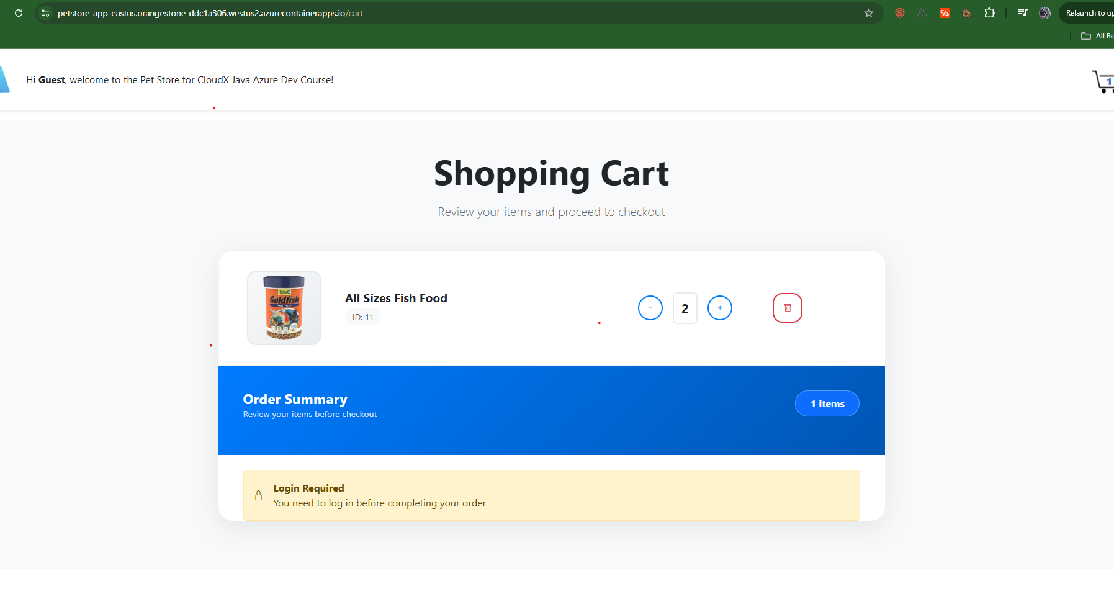
Screenshots illustrating the content and structure of a generated JSON file in Blob Storage.
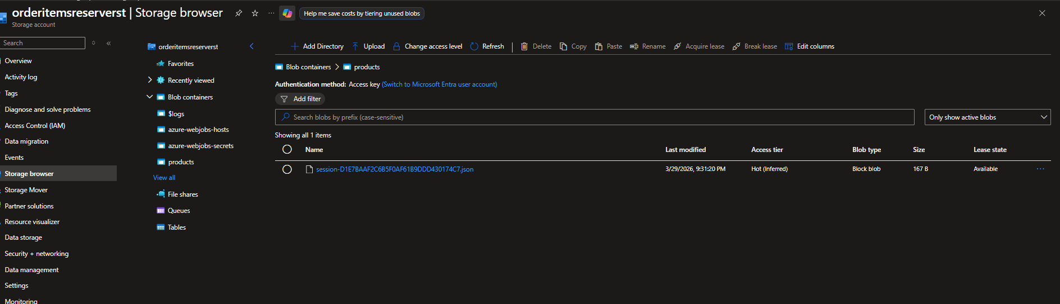
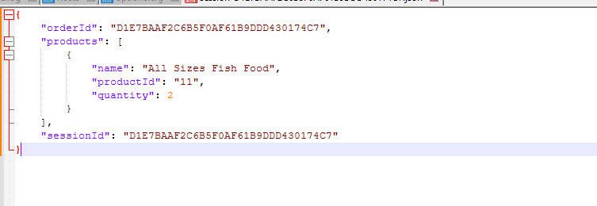
Screenshots confirming that the JSON file is overwritten with each user session update.
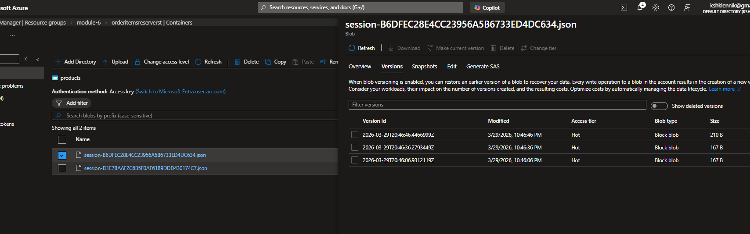
A screenshot showing the list of Azure resources that correspond to the diagram
